Objectives:

* Creating Lists and Tuples

**There are 3 projects, each is worth 33.3%.**

**Project #1:** write the following program and get the output in a console and a text file.

**#1 print screen the output with code below here.**

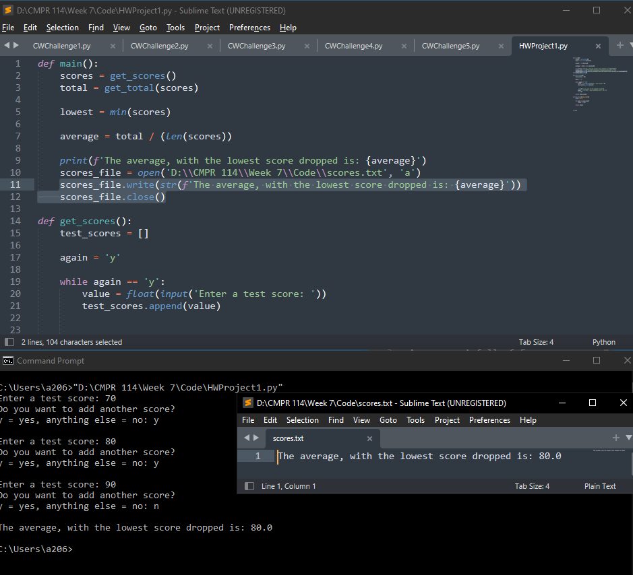

**Project #2:** complete the following program below

**#2 print screen the output with code below here.**

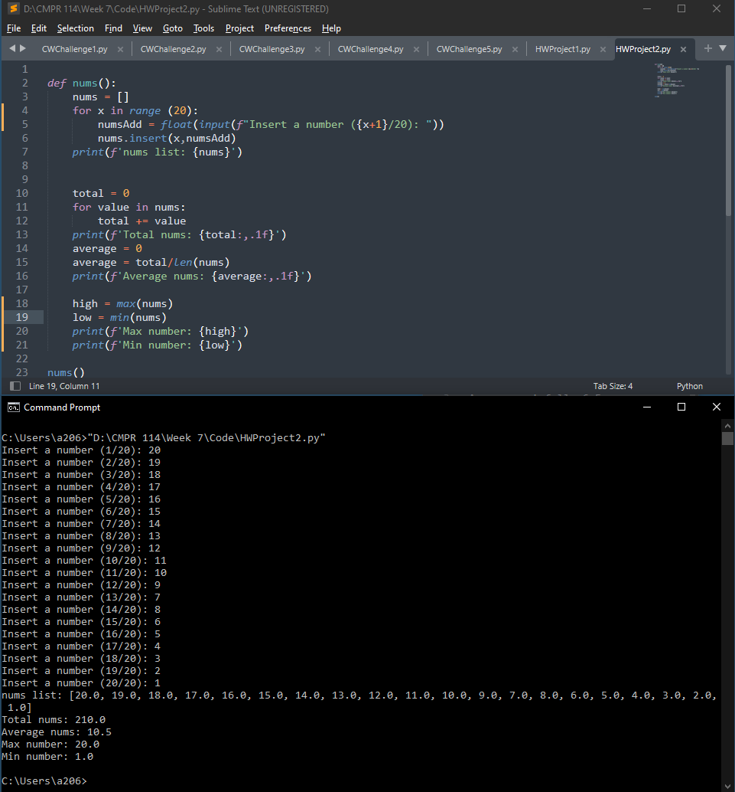

**Project #3:** complete the following program below. Research the most popular names on the Internet.

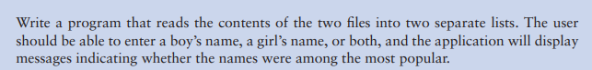

**#3 print screen the output with code below here.**

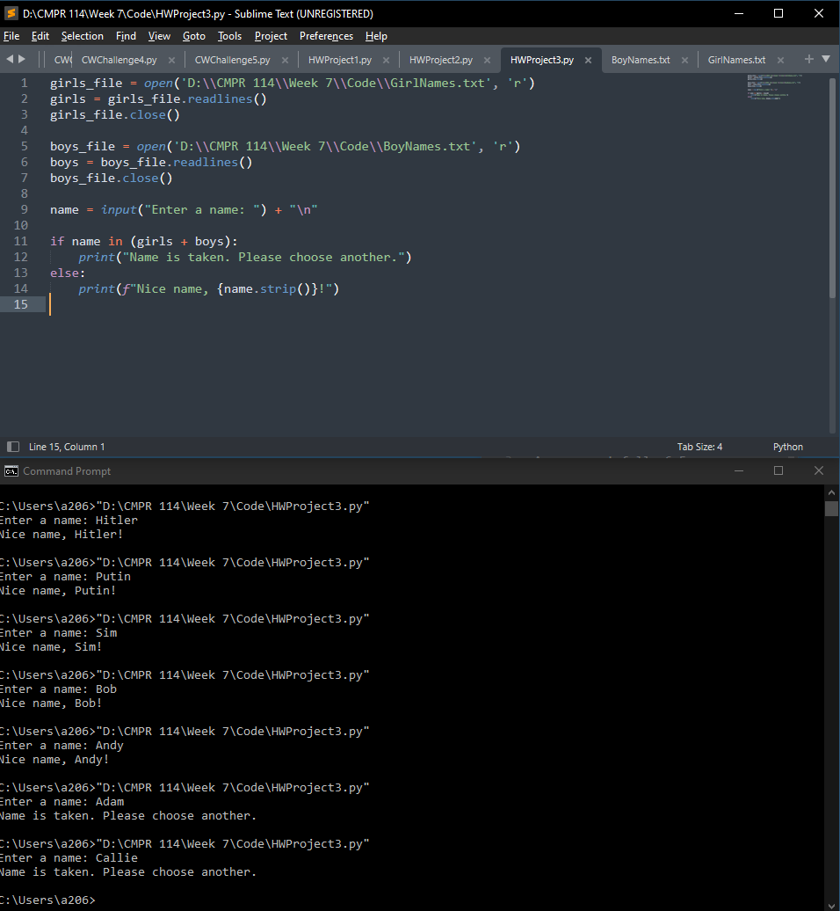

**Submit this document to Module 7 homework.**